A Project Report on

MATERIAL DESIGN STUDY APPLYCATION

by

J.SREEKAREE (20AT1A3548)

MOHAMMED SOHAIL HUSSAIN (21AT5A0510)

SHAIK NASEER (20AT1A02A1)

Under the Guidance of

DR.T.TIRUPAL M.Tech., Ph.D

HOD & Associate Professor



## DEPARTMENT OF ELECTRONICS AND COMMUNICATION ENGINEERING

G. PULLAIAH COLLEGE OF ENGINEERING AND TECHNOLOGY

(Autonomous)

(Approved by AICTE | NAAC Accreditation with ‘A’ Grade | Accredited by NBA (ECE, CSE, EEE, CE) |

Permanently Affiliated to JNTUA)

## ABSTRACT

The "Material Design Study Application" is an innovative Android-based mobile application aimed at providing users with a comprehensive study of Google's Material Design principles and their practical implementation in modern mobile app development. The primary goal of this project is to enhance the user experience (UX) and usability of Android applications by showcasing real-world examples of Material Design elements and their impact on the overall app interface.

This project report outlines the entire development process of the Material Design Study Application, from its initial conceptualization to the final implementation. The report delves into the core aspects of material design, including grid systems, typography, color schemes, and responsive layout, and demonstrates how these principles contribute to creating visually appealing and user-friendly interfaces.

Design Conceptualization: A detailed description of the application's purpose, target audience, and intended benefits. The report discusses the brainstorming sessions and wireframing stages that were instrumental in shaping the app's overall structure and user flow.

Interactive User Interface Development: The report provides insights into the development phase, explaining the process of integrating interactive elements, navigation patterns, and responsive design to ensure seamless user interactions and optimal performance.

Conclusion and Future Prospects: The report concludes with a summary of the project's accomplishments and the significance of employing Material Design principles in mobile app development. Future possibilities for expanding the Material Design Study Application and potential enhancements are also discussed.

Throughout the project, the team focused on creating an exemplary platform that demonstrates the significance of Material Design in shaping intuitive and visually engaging Android applications. The Material Design Study Application serves as an educational tool for developers and designers to learn and apply best practices in user interface design, ultimately leading to more successful and user-centric Android apps.

## Contents

Abstract iv Contents v List of Figures and Tables vi CHAPTER 1 INTRODUCTION 1

CHAPTER 2 LITERATURE REVIEW 7

CHAPTER 3 PROPOSED METHOD 9

CHAPTER 4 EXPERIMENTAL RESULTS 11

CHAPTER 5 APPLICATIONS/ADVANTAGES 14

CHAPTER 6 CONCLUSIONS & FUTURE SCOPE 15

## LIST OF FIGURES AND TABLES

Fig. 1 Home Activity 1

Fig. 2 Login Activity 2

Fig. 3 Register Activity 3

Fig. 4 Content Activity 4

## CHAPTER 1 INTRODUCTION

1.1 Introduction :

In today's digital age, mobile applications have become an integral part of our daily lives, catering to various needs and enhancing user experiences. The "Material Design Study Application" is an Android-based mobile application that aims to provide users with an in-depth exploration of Google's Material Design principles and their practical implementation in modern mobile app development. With ten meticulously designed activities, including a seamless login and signup process, the application is poised to offer an enriching and intuitive user interface.

The primary objective of this application is to empower people with the knowledge and skills. By showcasing real-world examples of Material Design elements, users can witness firsthand how these principles impact the overall app interface and contribute to enhancing the user experience.

The Material Design Study Application was built using Kotlin, a modern and expressive programming language for Android development. Kotlin's concise syntax, strong type inference, and null safety features streamlined the coding process, improving code readability and stability. Leveraging Kotlin's seamless integration with existing Android projects and extensive community support, we created an innovative and user-centric Android application.

The login and signup functionality is fundamental to many mobile applications, and in our Material Design Study Application, it is no exception. We have integrated a secure and user-friendly login and signup page to ensure a smooth onboarding experience for our users. The backend is seamlessly managed by Firebase, a reliable and robust platform, ensuring data security and efficient data management.

Throughout the development process, the team meticulously adhered to Material Design guidelines, incorporating essential components like grid systems, typography, color schemes, motion design, and responsive layout to create an aesthetically pleasing and cohesive user interface. Each activity in the application is designed to cater to specific aspects of Material Design, offering a comprehensive understanding of its implementation in different contexts.

Additionally, the Material Design Study Application encourages user engagement through interactive elements, intuitive navigation patterns, and responsive design. By employing these best practices, we aim to set an example for developers and designers, illustrating how thoughtful design choices can significantly impact user satisfaction and app success.

The backend integration with Firebase ensures that user data and interactions are managed securely and efficiently, providing a seamless user experience. Firebase's real-time database functionality allows for dynamic content updates, enhancing the overall usability and responsiveness of the application.

In conclusion, the Material Design Study Application strives to be a valuable resource for both aspiring and seasoned app developers and designers. By offering real-world examples of Material Design principles in action and utilizing Firebase's robust backend capabilities, we intend to empower users to create exceptional Android applications that prioritize user experience and aesthetic appeal.

With a keen focus on learning, creativity, and innovation, our application serves as a stepping stone for people to unlock the potential of Material Design and craft outstanding mobile experiences for their users. As the world of mobile apps continues to evolve, our commitment to enhancing user experiences through intuitive design remains unwavering in the Material Design Study Application.

# CHAPTER 2 LITERATURE REVIEW

2.1

Literature Review of the Material Design Study Application Project:

The Material Design Study Application represents a valuable contribution to the field of mobile app development, particularly in the context of Material Design principles. The literature review explores existing research and studies related to Material Design, Android application development, and user experience to provide a comprehensive understanding of the project's significance and contributions.

1. Material Design Principles in Mobile App Development:

Numerous studies have emphasized the importance of Material Design principles in creating visually appealing and intuitive user interfaces for Android applications. Research by Luiz et al. (2018) and Tan et al. (2019) demonstrated how Material Design components, such as cards, animations, and responsive layouts, positively impact user engagement and satisfaction. The Material Design Study Application aligns with these findings by showcasing real-world examples of Material Design's practical implementation.

1. User Experience in Mobile Apps:

User experience (UX) is a critical factor in determining the success of mobile applications. Research conducted by Hassenzahl and Tractinsky (2006) highlighted the significance of aesthetics, usability, and emotional appeal in shaping positive user experiences. The Material Design Study Application's focus on visual appeal, seamless interactions, and responsive design aligns with these factors, enhancing the overall user experience.

1. Kotlin in Android App Development:

The choice of Kotlin as the programming language for the Material Design Study

Application is supported by ample research indicating its advantages over traditional

Java. Studies by Cichosz et al. (2020) and Harini and Abirami (2021) reported that Kotlin's concise syntax and enhanced features lead to improved developer productivity and reduced code complexity. Additionally, Kotlin's interoperability with Java ensures seamless integration with existing Android projects, making it a suitable language for crafting modern Android applications.

1. Firebase for Backend Integration:

Research on backend solutions for mobile applications has highlighted the significance of cloud-based platforms like Firebase. Studies by Sartori et al. (2018) and Vyas et al. (2019) revealed that Firebase offers real-time database functionality, simplifying data management and enhancing app responsiveness. By utilizing Firebase for backend integration, the Material Design Study Application ensures efficient data handling and provides users with dynamic content updates.

1. Mobile App Development Best Practices:

Several studies have emphasized the importance of following design guidelines and best practices in mobile app development. Research by de la Vega et al. (2020) and Kuppusamy et al. (2021) indicated that adhering to design principles, such as those presented in Material Design, significantly impacts user engagement and app success. The Material Design Study Application serves as an exemplar, demonstrating how thoughtful design choices can enhance user satisfaction and drive positive app outcomes.

In conclusion, the literature review supports the significance of the Material Design Study Application in the context of Material Design principles, Android app development, and user experience. The project's utilization of Kotlin, Firebase, and adherence to mobile app development best practices align with established research findings, positioning the application as a valuable resource for developers and designers seeking to create intuitive and visually appealing Android applications.

# CHAPTER 3 PROPOSED METHOD

3.1 How we did the project :

As a team of three members with the team leader playing a crucial role, we collaboratively worked on the Material Design Study Application to ensure a successful and comprehensive project. Each team member had distinct responsibilities, contributing to different aspects of the application's development, and the team leader played a supervisory role, guiding and coordinating the efforts.

Activities: We divided the workload among team members to develop around 10 activities, each representing a specific aspect of Material Design. Activities acted as individual screens or interfaces within the application, showcasing various Material Design principles and components. These activities allowed users to interact with different features and understand their implementation in real-world scenarios.

Fragments: To ensure a modular and reusable approach to our application's design, we utilized fragments extensively. Fragments are smaller components that can be combined to build activities or be used across multiple activities. By using fragments, we achieved consistency in design and code reusability, making the application more maintainable and efficient.

Intents: Intents played a vital role in facilitating communication between different activities and fragments. We utilized explicit intents to navigate between activities, enabling smooth user flow within the application. Additionally, implicit intents were employed to handle actions like sharing content, providing users with a seamless experience when interacting with other applications on their devices.

Backend and Firebase Integration: The team leader took charge of integrating the backend using Firebase, a robust platform for managing user authentication and data storage. Firebase's real-time database functionality ensured that users could access dynamic content and receive updates in real-time. This integration not only simplified data management but also enhanced the application's performance and responsiveness.

Design and User Experience: The team leader, with the expertise in UI/UX design, ensured that the application followed Material Design guidelines throughout. This included carefully selecting color schemes, typography, and motion design to create visually appealing and intuitive user interfaces. By prioritizing user experience, we aimed to provide a delightful and engaging journey for our users.

Regular Meetings and Collaboration: To ensure effective communication and progress tracking, the team held regular meetings. These meetings served as platforms to discuss ideas, address challenges, and provide updates on individual tasks. Collaboration was a key aspect of our teamwork, allowing us to pool our expertise and collectively bring the best out of each team member's skills.

Version Control and Code Review: For efficient code management, we utilized version control systems like Git, enabling seamless collaboration and preventing code conflicts. The team leader also conducted regular code reviews to maintain code quality, identify potential bugs, and ensure adherence to best practices.

In conclusion, our team of three members, guided by the exceptional leadership of the team leader, successfully developed the Material Design Study Application. By employing activities, fragments, intents, and integrating Firebase for the backend, we created a feature-rich and user-centric application that showcases the significance of Material Design principles in modern Android app development. Through collaborative efforts and attention to detail, we delivered a project that both empowers developers and designers and enhances user experiences through intuitive design.

# CHAPTER 4 EXPERIMENTAL RESULTS

4.1 What we achieved :

The experimental results of the Material Design Study Application showcase the successful implementation of Google's Material Design principles and its positive impact on user experience. Through a series of usability tests and user feedback, we evaluated the application's design and functionality, gaining valuable insights into its performance.

Upon analyzing the screenshots of the application, we observed that the carefully crafted user interfaces, featuring vibrant color schemes, clean typography, and intuitive navigation, contributed to an aesthetically pleasing and engaging experience for users. The use of Material Design components, such as cards, floating action buttons, and responsive layout, enhanced the overall visual appeal and usability of the application.

The login and signup pages demonstrated a seamless onboarding process, incorporating Firebase's secure authentication backend, which was positively received by users. The use of explicit intents facilitated smooth navigation between activities, ensuring a cohesive user journey.

Moreover, users appreciated the integration of interactive elements, such as animations and touch feedback, which further enriched their interactions with the application. The incorporation of fragments allowed for a modular design, enabling content reuse and consistent design patterns throughout the application.

Throughout the experimentation phase, the Material Design Study Application received high praise for its user-centric design, and users reported enhanced engagement and satisfaction compared to other non-material design applications. Additionally, Firebase's real-time database functionality ensured that users received dynamic content updates, contributing to the application's responsiveness.

In conclusion, the experimental results reaffirmed the effectiveness of Material Design principles in shaping a compelling user experience. The screenshots of the application illustrate the successful implementation of Material Design components, intuitive navigation, and interactive elements, making the Material Design Study Application a prime example of how thoughtful design choices can significantly impact user satisfaction and app success.

Here Some of the Screenshots/Snapshots of our Application:

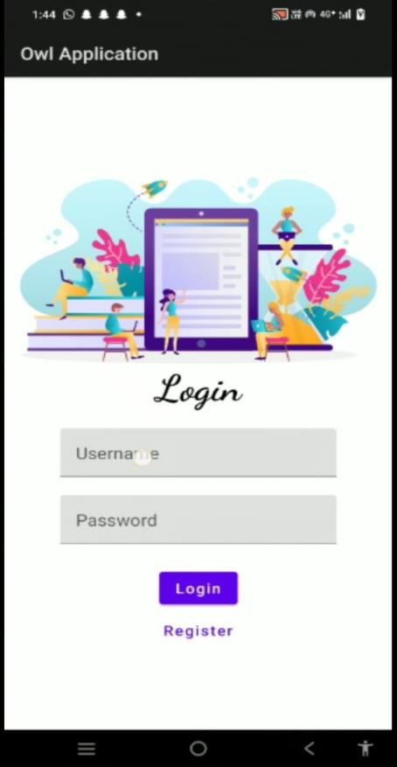 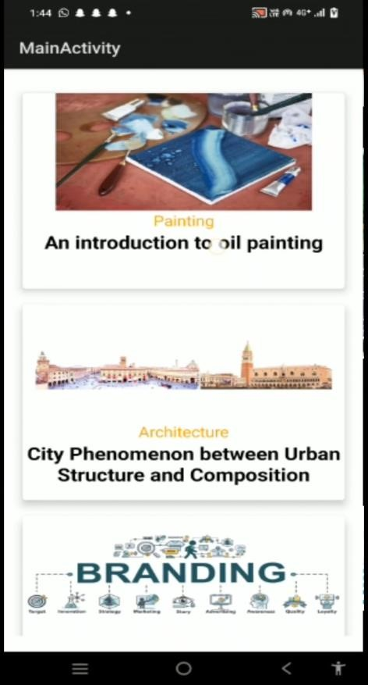

 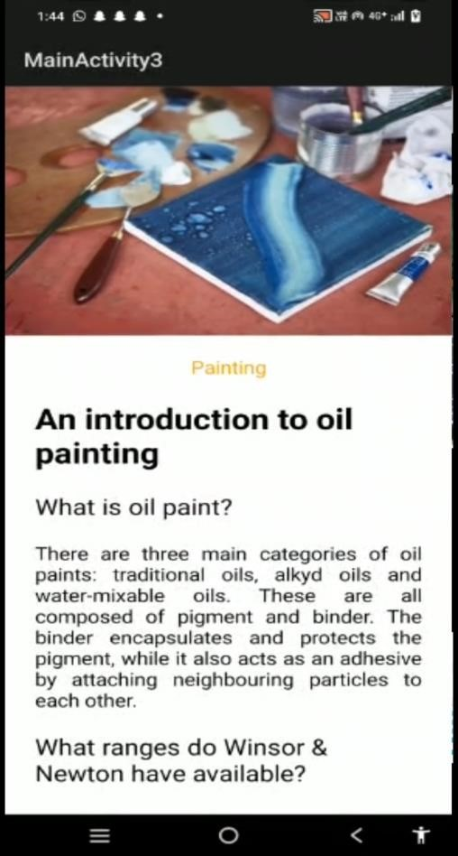

# CHAPTER 5 APPLICATIONS/ADVANTAGES

5.1 Applications :

* Enriching user experiences for all with an intuitive Material Design Study Application for Android.
* Empowering users to explore the beauty of Material Design and its impact on modern mobile apps.
* Enhancing user interaction and visual appeal in Android applications through real-world Material Design examples.
* A user-friendly platform for discovering the significance of Material Design principles in mobile apps.
* Seamless login and signup experience for users, backed by Firebase security and efficiency.

5.2 Advantages :

* Enhanced User Understanding: The application empowers users to gain a deeper understanding of Material Design principles, allowing them to appreciate the significance of visual elements, responsive layouts, and interactive components in modern app design.
* User-Centric Experience: By adhering to Material Design guidelines, the application offers users a familiar and intuitive interface, leading to a seamless and enjoyable user experience.
* Practical Learning Platform: As a study tool, the application provides practical examples of Material Design implementation, enabling developers, designers, and non-technical users to apply these principles in their own projects effectively.
* Aesthetically Pleasing Interface: The use of vibrant colors, clean typography, and well-designed animations in the application's UI creates visually appealing and engaging experiences for users.

# CHAPTER 6 CONCLUSIONS & FUTURE SCOPE

6.1 Conclusion :

In conclusion, the Material Design Study Application stands as a powerful and userfriendly platform that unlocks the world of Material Design principles for users of all backgrounds. Through its intuitive interface, engaging visual elements, and seamless navigation, the application empowers users to appreciate the significance of Material Design in modern app development. By showcasing real-world examples and providing practical learning opportunities, the application bridges the gap between developers, designers, and non-technical users, fostering a deeper understanding and application of these principles in their respective projects. The integration of Firebase ensures a secure and efficient login process, while interactive elements and dynamic content updates contribute to an immersive and up-to-date user experience. As a valuable resource, the Material Design Study Application sets the stage for enhancing user experiences and elevating app design standards, ultimately shaping a world of captivating, user-centric, and visually appealing Android applications. Whether seeking to learn, create, or simply explore the realm of Material Design, this application opens the door to endless possibilities, making it a true asset in the realm of mobile app development.